V’ sham’ru

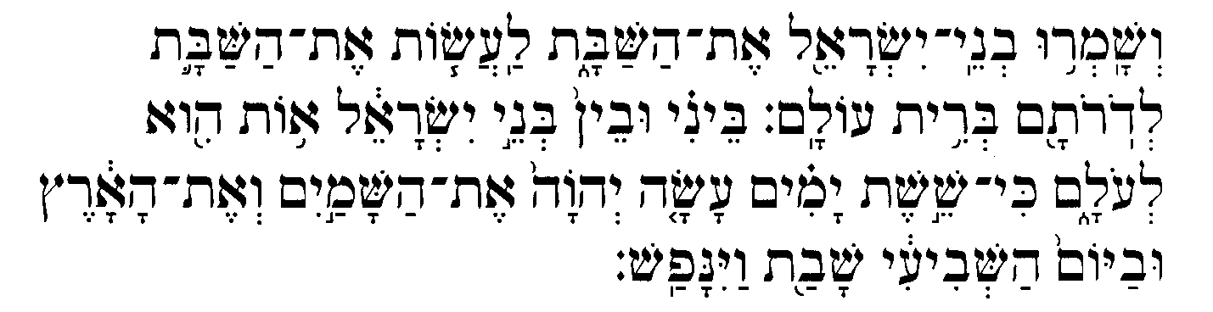

Exodus 31: 16-17

The Israelite people shall keep the sabbath, observing the sabbath throughout the ages as a covenant for all time: it shall be a sign for all time between Me and the people of Israel. For in six days the LORD made heaven and earth, and on the seventh day He ceased from work and was refreshed,

Chemjo Vinaver (sung in the liturgy)

Torah Trope

Charles Davidson (Sephardic Service)

Richard Botton, arr. Stephen Richards

Aminadav Aloni

Max Helfman (Shabbat Kodesh)
Soloist: Emily Eyre

Fill our hearts with Sabbath peace and serenity, that we may hear the voice of Thy spirit.
Union Prayer Book, page 59

